## Electrolyzes:

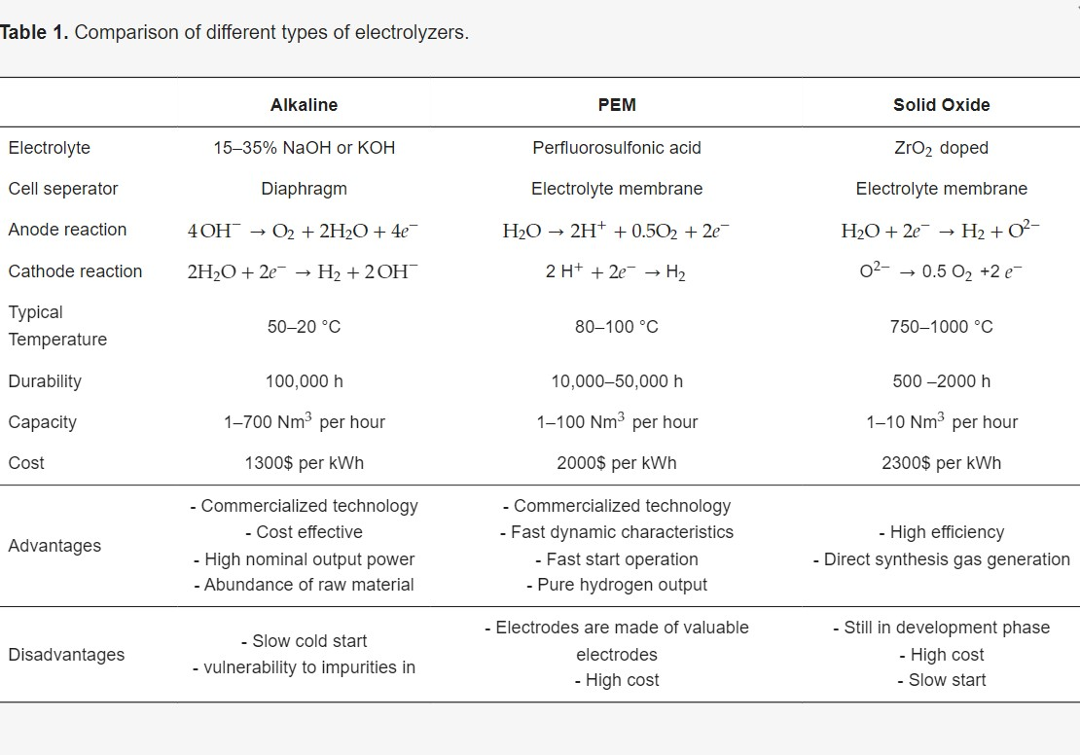

## The Prototype:

The prototype of the training equipment consists of an electrolyzer, two fuel cells, a variable resistor, a light bulb, and an electric motor, as shown in Figure 3. The electrolyzer is a device used for the electrolysis of water. It consists of two water tanks filled with different gases during the electrolysis process. The tank marked with H2 is filled with hydrogen, while the tank marked with O2 is filled with oxygen, as shown in Figure 4. A fuel cell is an electrochemical device that works on the principle of converting chemical energy into electrical energy, similar to a battery, but cannot store electrical energy.

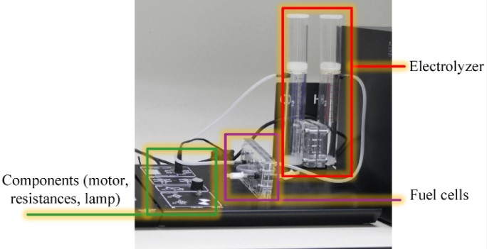

The educational prototype of the fuel cell

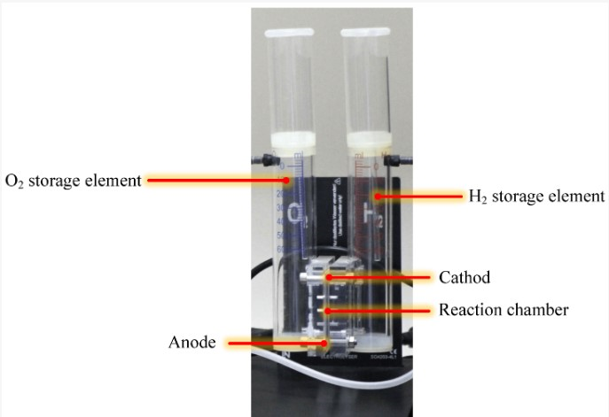

The electrolyzer.

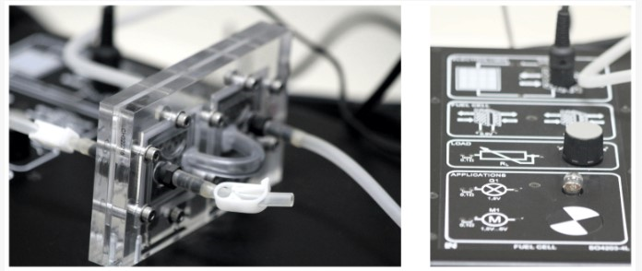

Fuel cells (left) and various electric loads (right).

## Experimental Setup:

Along with the model, a software part was also prepared: the interface to the portable educational prototype, where experiments can be performed with the education prototype are proposed. The list of experiments is shown in the picture below.

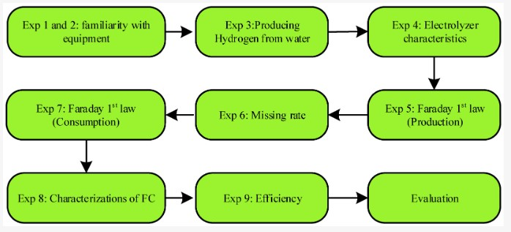

### First and Second Experiment: Familiarity with the Equipment:

* The first and second experiments introduce learners to the prototype. These two experiments illustrate the connection between the electrolyzer, fuel cells, and the motor as a load. First, the electrolyzer is turned on, producing oxygen and hydrogen, which are brought to the fuel cells through pipes in a gaseous state. Then, in the cells, the chemical energy of the gases is converted into electricity, which drives the connected engine. In the second part, voltage, current, and power are measured, and the V-I characteristic of series-connected fuel cells is recorded.

The voltmeter measurements show the result of the second part, in which the voltage of the motor connected to the series connection of the fuel cells is measured. The result is *V* = 1.65 V. It is written on the model that one cell gives a voltage of 0.9 V. The measurements show a voltage drop of 0.15 V on the measuring instruments. The current measurement indicates that *I* = 0.012 A. The active power of the consumer is determined by using a wattmeter, which indicates that *P* = 0.02 W. This reading can also be checked using the power equation 𝑃=𝑉×𝐼=1.65×0.012=0.0198�=�×�=1.65×0.012=0.0198 W, which is close to the one indicated by the wattmeter.

### Third Experiment: Water = **H2𝑂:**

* The experiment aims to conduct electrolysis of water and pay attention to the amount of oxygen and hydrogen produced. From the already-known chemical notation (H2O), it can be noticed that water contains two atoms of hydrogen and one of oxygen, which means that the hydrogen produced is twice the oxygen produce**d.** It is also demonstrated that the experiment produced 60 mL of hydrogen and 30 mL of oxygen, proving the composition of H22O, two hydrogen atoms, and one oxygen atom.

### Fourth Experiment: Electrolyzer Characteristics:

* In this experiment, the characteristics of the electrolyzer are investigated. The investigation is completed by connecting the electrolyzer to an external power source. Then gradually increasing the electrolysis current. The characteristic is recorded using an interface program. Figure 10 shows that no current flows through the electrolyzer until a voltage of 1.4 V is reached. That means that until the threshold voltage of 1.4 V is reached, the electrolyzer will not start the electrolysis process. This alone will not provide fuel for the fuel cell, and it can also be seen that the maximum power of the electrolyzer is approximately 3.8𝑊

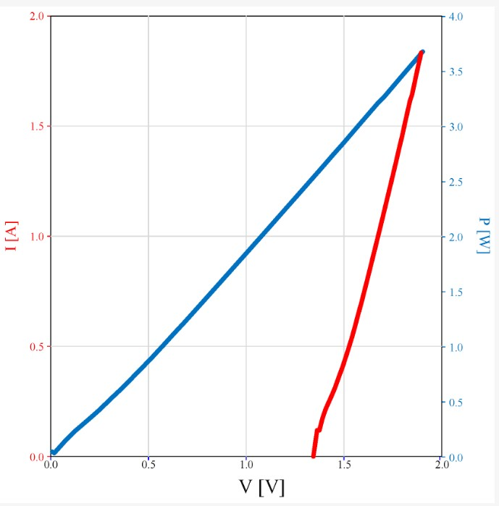

### Fifth Experiment: Faraday’s First Law: Production of **𝐻2:**

### Sixth Experiment: Missing Rate:

### Experiment 8: Characterization of Fuel Cells:

This experiment consists of three parts, V-I characteristics curve of fuel cells is examined for a single fuel cell and also different connections, which can be either serial or parallel. This portable prototype contains two fuel cells on which experiments are carried out. The first part investigates the characteristics of a single fuel cell. The tank is filled with hydrogen, and the variable resistor is set to the highest resistance. The characteristic of the fuel cell is then recorded, and the resistance is gradually reduced during the recording. The connection diagram is shown in [**Figure 13**](https://www.mdpi.com/2076-3417/13/1/608#fig_body_display_applsci-13-00608-f013), which also the V-I characteristic curve of a single fuel cell. The Figure also shows that the maximum voltage of one fuel cell is approximately equal to 𝑉𝑚𝑎𝑥=0.9 and decreases almost linearly with increasing resistance. From the characteristics curve, the maximum power is about 𝑃𝑚𝑎𝑥=0.45. In the second part of the experiment, the cells are connected in parallel, and the measurement procedure is repeated. First, the tank is filled with 60 mL of hydrogen, then the variable resistor is set to the highest possible value, and then the characteristic is recorded. During recording, the resistance of the variable resistor decreases. The connection diagram is shown in [**Figure 14**](https://www.mdpi.com/2076-3417/13/1/608#fig_body_display_applsci-13-00608-f014), which also shows the obtained characteristic curve. This characteristic ([**Figure 14**](https://www.mdpi.com/2076-3417/13/1/608#fig_body_display_applsci-13-00608-f014)) shows that the maximum voltage is approximately equal to 𝑉𝑚𝑎𝑥=0.9. The maximum current is significantly higher than the previous characteristics curve. A parallel connection is used in applications where the voltage should remain approximately the same as the load current increases. In this case, the load is a variable resistor. In the third part, the characteristic of serially connected fuel cells is recorded according to the scheme of [**Figure 15**](https://www.mdpi.com/2076-3417/13/1/608#fig_body_display_applsci-13-00608-f015). The hydrogen tank is filled as in the previous part, and the same process of recording the characteristics of the fuel cell is performed. It is assumed that the voltage must be doubled because two DC sources are connected in series, which means that now the maximum voltage should be 𝑉𝑚𝑎𝑥=0.9+0.9=1.8V.[**Figure 15**](https://www.mdpi.com/2076-3417/13/1/608#fig_body_display_applsci-13-00608-f015) shows that the maximum voltage is approximately equal to 𝑉𝑚𝑎𝑥=1.8V. It can be seen from the characteristic that this series connection is used in applications where the power stays relatively high with increasing load. The maximum power is approximately 𝑃𝑚𝑎𝑥=0.58W, while the maximum current is approximately 𝐼𝑚𝑎𝑥=1.2A.

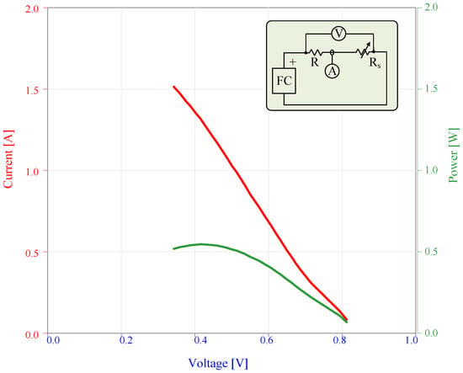

**Figure 13.** The characteristic V-I curve (red) and V-P curve (green) for a single FC. The test circuit and the FC connection is shown in the upper right corner.

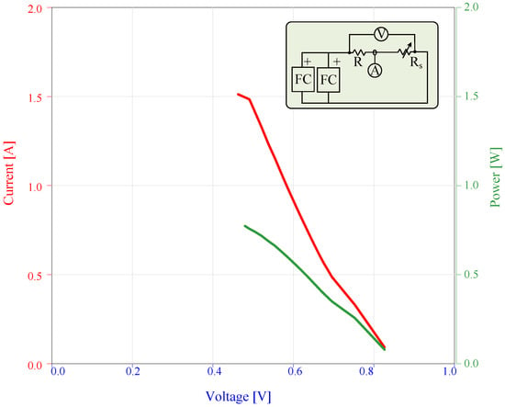

**Figure 14.** The characteristic V-I curve (red) and V-P curve (green) for parallel-connected FCs. The test circuit and the parallel connection of FCs is shown in the (upper right corner of the graph).

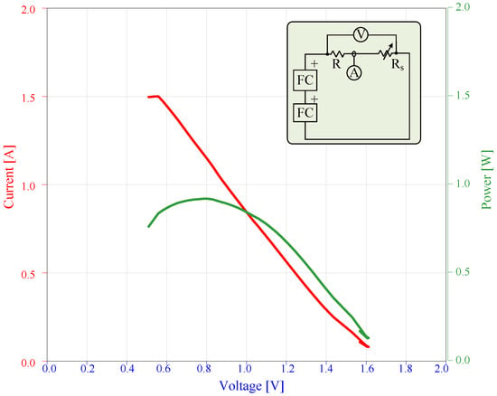

**Figure 15.** The characteristic V-I curve (red) and V-P curve (green) for serially-connected FCs. The test circuit and the series connection of FCs are shown in the (upper right corner of the graph).

### Efficiency of the Fuel Cell:

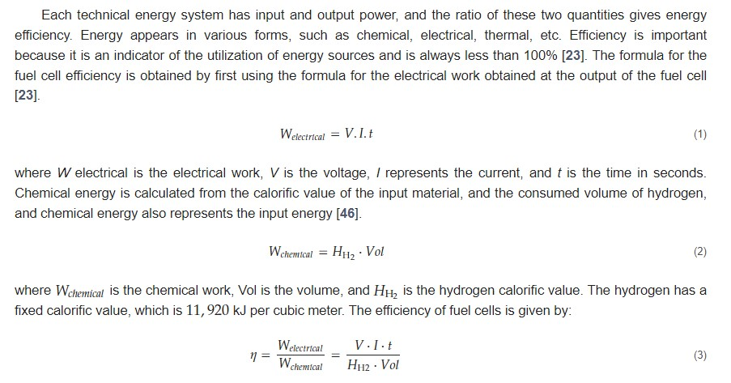

### Evaluation of the Characterization Results:

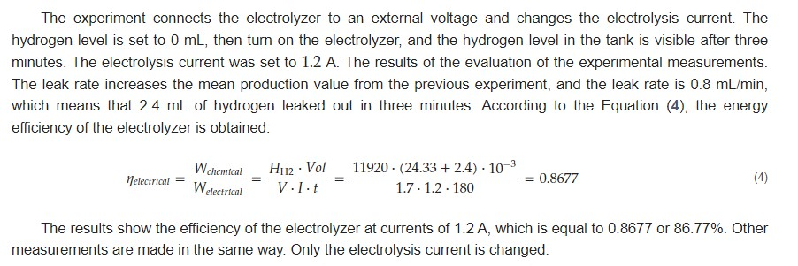

##### Serially-Connected FC:

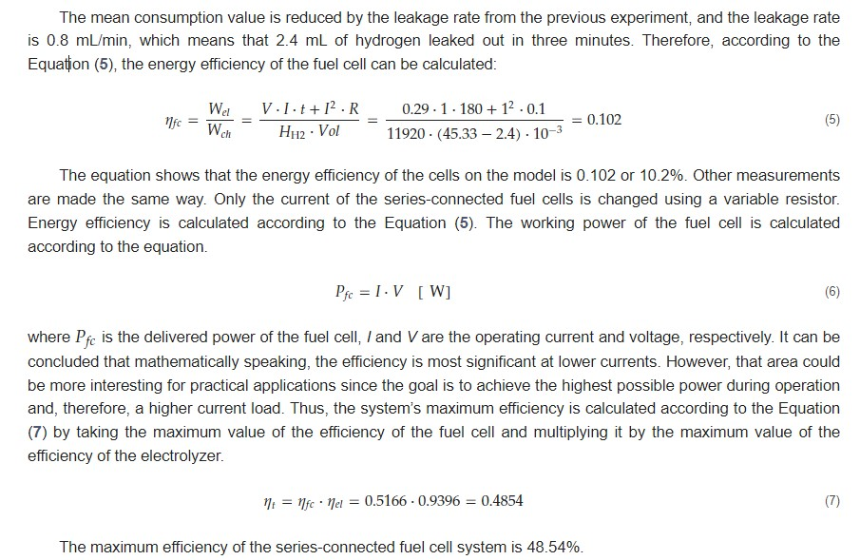

##### Parallel-Connected FC:

